Earthly Delight
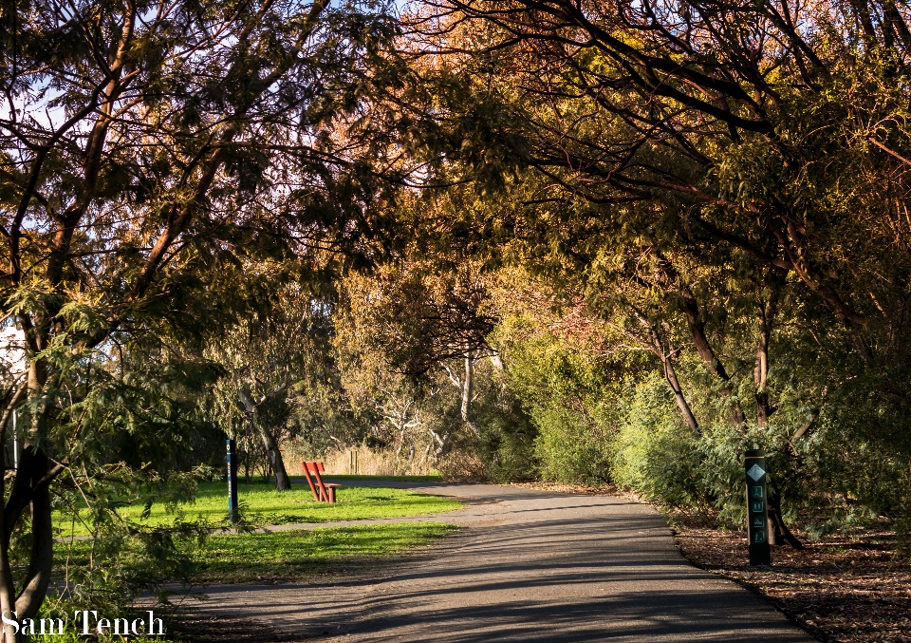
Lucky for me, this picturess location is just down the road from where I live. A scenic river trail, I have spent many afternoons taking pictures or simply getting away from the madness of life and taking a walk. I’m very familiar with this location but, as is the case with many things, it wasn’t until I began taking photo’s that I was able to see its true potential.
This shot was taken very early on in my photographic experience and considering the bright and glaring conditions I was working with, this photo taken alongside the Barwon River was one I was happy to shoot. The heavily draping trees, revealing an artwork of shadows projected onto an otherwise boring footpath and grass area, along with the earthy tones of autumn makes this a picture an earthly delight.

